Top Up your Competition Purse On-Line – Sample Screen Views
*This version is for desk-top users.
The process can also be done using a smart phone following the same steps but the screen views will be slightly different.

- Logon as normal to the Roscommon BRS member site to make a tee- time booking. You should have your credit/debit card to hand as you will need it. You will see the following booking information screen.

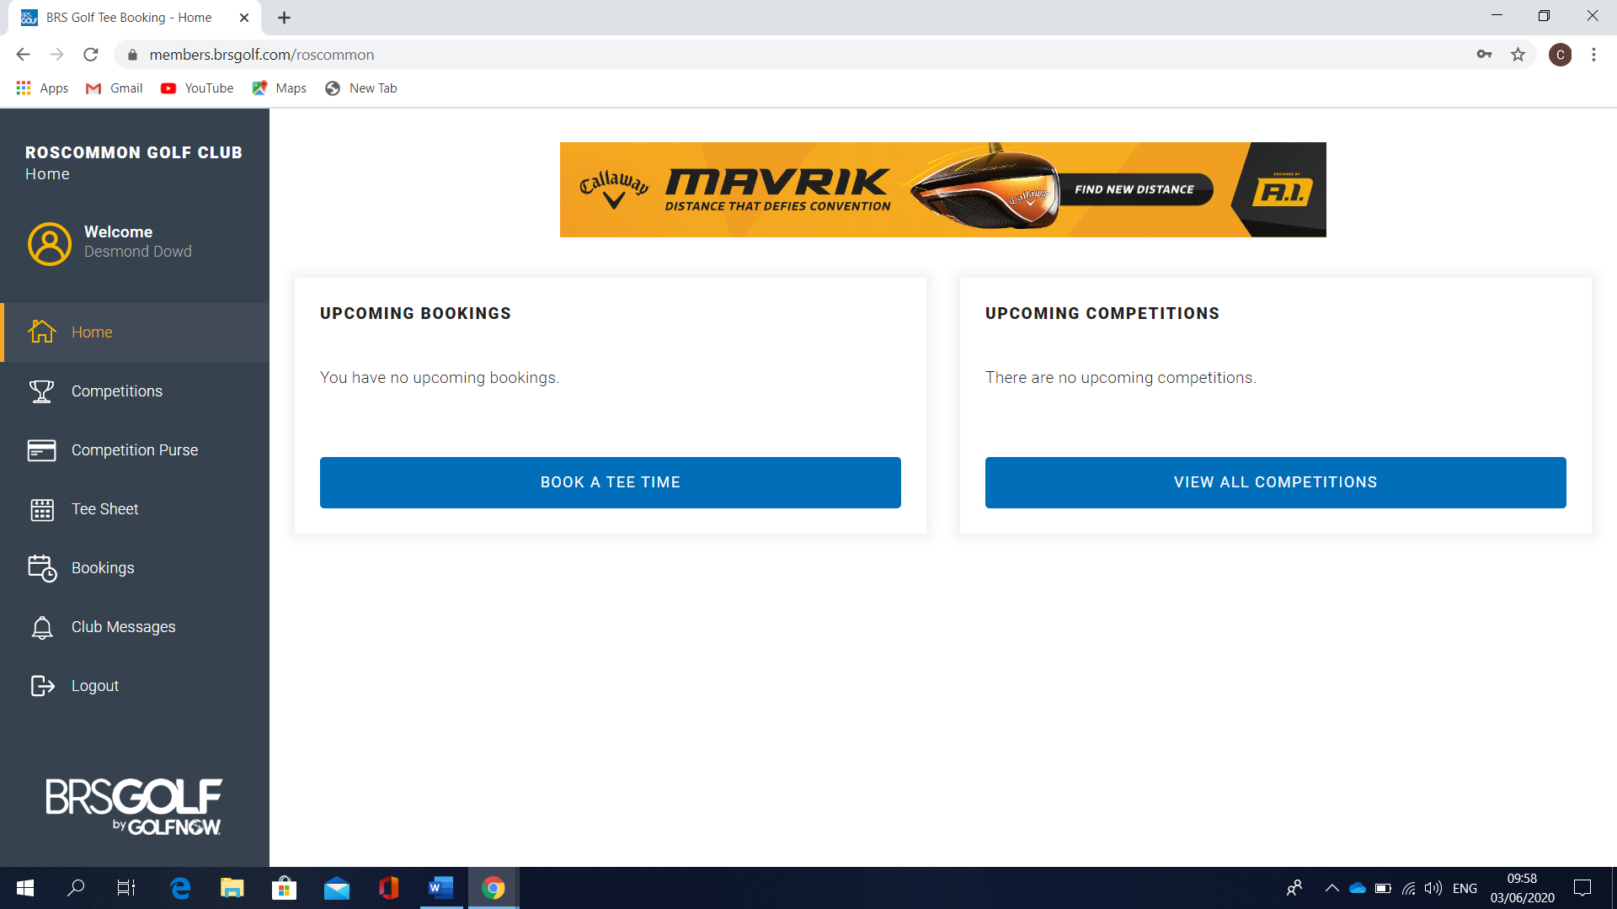

- Where you see ‘Welcome’ and your name underneath on the left side of your screen you click on this and check that your address details are entered and that the address is that of the card you will be using. Once done click ‘save changes’. This will only have to be done for the initial top up. Click on the “Top Up” button. Press the ‘Competition Purse’ tab on the left hand side of your screen. You will be presented with the following screen:

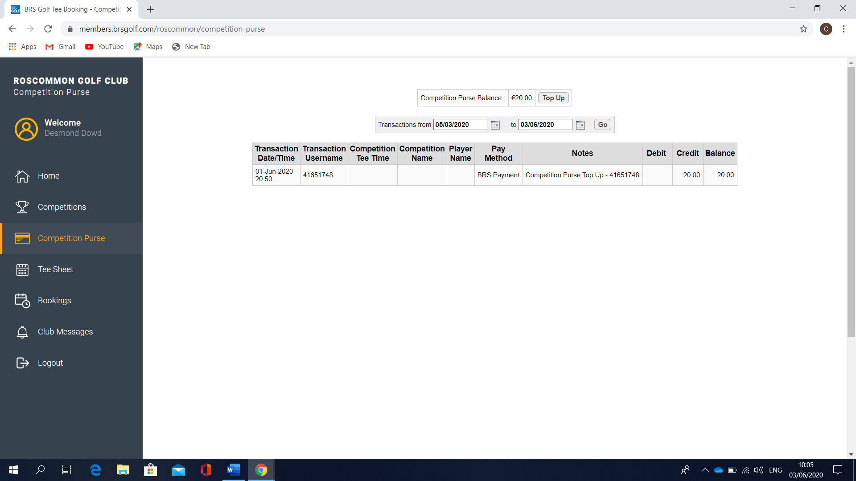

- Press the ‘Top Up’ tab and select the amount of money you wish to place on your purse. You will then be shown this screen which will have your details on it.

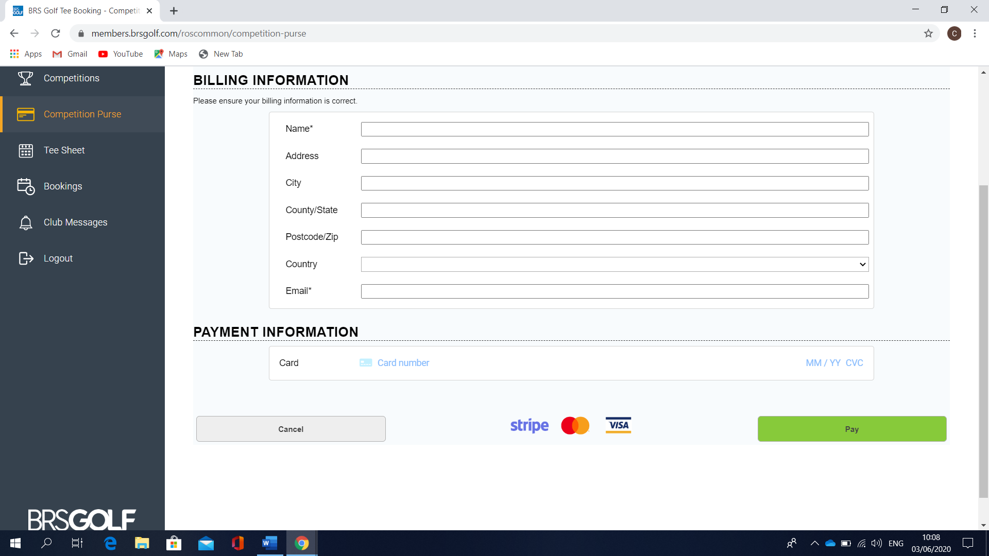

- Provide your card details and hit ‘Pay’ to make payment. If you have entered the correct details, you will get confirmation of a successful top up. You will also receive a confirmation email telling you of same.

